

The Chapel of
Our Lady of the Angels

By Simon Peaple BA PhD GCTC

Incorporating
The Angels of
Our Lady of the Angels

By Francis Young

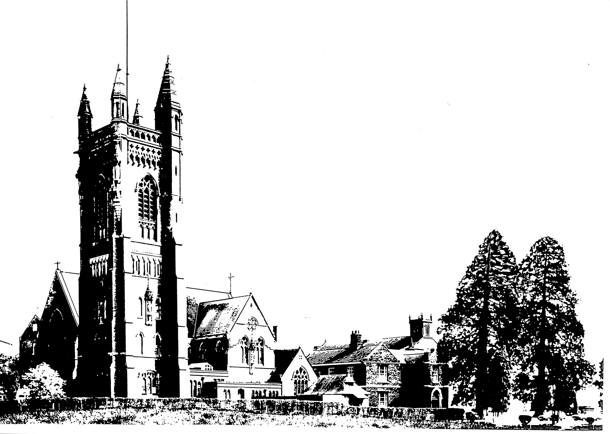

Contents

1. Plan of the Chapel 3

2. The Chapel of Our Lady of the Angels 4
Background 4
Contextual Background 4
The Present Church 5
A Walking Tour of the Chapel 6

3. The Bells of the Chapel of Our Lady of the Angels 9

4. The Organ at the Chapel of Our Lady of the Angels 10

5. The Angels of Our Lady of the Angels 11
Introduction 12
1. The West Window: The Coronation of the Blessed Virgin Mary in Heaven 13
2. The Nuns’ Choir and Crossing 16
3. The Chapel of the Sacred Heart 17
4. The Baldachin 17
5. The High Altar 19
6. The Apsidal Windows 20
7. The Ambulatory and Chapels 21
8. The Exterior 22

Plan of the Chapel

The Chapel of Our Lady of the Angels

Background

The church of Our Lady of the Angels was built between 1897 and 1901 to replace a smaller church constructed in 1836. The new church formed the focal point for worship for the Benedictine Priory which was built between 1832 and 1835, and which was occupied by a community of Benedictine nuns until 1965, when it was taken over by the Missionaries of the Sacred Heart, who founded Princethorpe College.

Contextual Background

The church and priory were established in the 1830s following the passing of the Catholic Emancipation Act in 1829 which repealed most of the penal laws enacted after 1688. Between 1689, when Parliament voted to bestow the crown jointly upon the protestant William III (William of Orange) and his wife Mary II, daughter of James II, Roman Catholics in Britain were subject to both legal restrictions and penalties, limiting their ownership of property and participation in civic life. Whilst the harshness of the various laws varied over time, they remained in place until the nineteenth century.

During the 1820s, Catholicism in Britain saw an increase in numbers, due not only to conversions amongst the gentry but also large scale immigration of working class Irish people drawn to the mainland by work on the canals or “navigations” – hence the term “navvies”.

The issue of Catholic emancipation had led to the resignation of Pitt the Younger in 1801. Emancipation had been promised as part of the negotiations for the Act of Union between Ireland and Great Britain, and Pitt had felt obliged to resign when King George III refused to sanction Catholic Emancipation on the grounds that it would break his coronation oath.

Catholic Emancipation then remained a closed question during the period of Lord Liverpool’s premiership from 1812 to 1827, as he recognised its potential for dividing the Tory party. Although King George IV (1820-1830) had secretly been married to a Catholic, Maria Fitzherbert, in the last years of his reign he became strongly anti-Catholic under the influence of his last two mistresses, Lady Hertford and Lady Conyngham.

Following Lord Liverpool’s death in 1827, and the short premiership of Canning, the Duke of Wellington became Prime Minister with Sir Robert Peel as Home Secretary. Canning was a controversial figure and supported Catholic emancipation and Peel (nicknamed “Orange Peel” because of his supposedly strong Protestantism as Chief Secretary in Ireland under Liverpool), had refused to serve under Canning. With Peel’s return to government the pendulum within the Cabinet swung the other way, and the more moderate Huskisson resigned from the government.

To replace Huskisson as President of the Board of Trade it was decided to appoint Lord Fitzgerald, the Member of Parliament for County Clare. By the convention of the times, Lord Fitzgerald had to seek the approval of his constituents by holding a by-election. Ministers had not anticipated the decision of Daniel O’Connell, a leading Catholic lawyer and campaigner for emancipation, to stand as a candidate.

O’Connell’s victory, his rejection by Parliament as being disbarred by his Roman Catholicism, and his subsequent re-election, led to Peel recommending to Wellington that the government approve Catholic emancipation. The relief of non-conformists (Protestants outside the Church of England in 1828), had set a precedent, and with the reluctant consent of King George IV, the Catholic Emancipation Orders passed a crucial second reading in the Commons on 18 June 1829, the fourteenth anniversary of the battle of Waterloo.

With the legalisation of Catholicism in England it was possible for Catholic religious orders to own property without fear of it being confiscated. The return of Catholic orders to England was further encouraged by events on the continent. In 1830, the revolution in France overthrew the strongly Catholic Charles X, whilst the Belgian war of independence began in order to end Dutch rule.

The Present Church

Work on the present church was begun in 1897, the year of Queen Victoria’s Diamond Jubilee, and completed in 1901, the year in which the longest reign of any British monarch came to a close at Osborne House on the Isle of Wight.

The cost of building the church was met by Lady Annette Mary de Trafford. She was the daughter of Lt.-Col. Charles Thomas Talbot (1782 – 1838) and Julia Tichborne (d. 1892). On 17 January 1855, Annette married Sir Humphrey de Trafford (1808 – 1886), 2nd Baronet. The couple had three children; Mildred Mary Josephine (1856 – 1934), Humphrey, later 3rd Baronet, (1862 – 1929) and Sicele Agnes (1867 – 1948). Annette’s sister Gwendoline married Edward Henry Petre who resided at Whitley Abbey in Warwickshire.

The title was taken from Trafford Park in Manchester. The Trafford family traces its lineage to Radulphus who died in 1050 during the reign of Edward the Confessor. The Traffords owned lands in Lancashire and Cheshire but remained Catholic despite the Reformation and were therefore excluded from civic life. Following Catholic emancipation in 1828, they rose to be Lord Lieutenants of Lancashire. Sir Dermot Humphrey de Trafford, 6th Baronet succeeded to the title in 1983. Lady Annette de Trafford left her legacy not only in the form of the chapel, but she also blooms today, between June and August, in the guise of a late flowering pink rhododendron, which can reach up to 7ft in height.

Lady Annette’s generosity in paying for the building of Our Lady of the Angels can be seen in the size of the bill. The estimates submitted by Pugin and Pugin amounted to some £6,500. In 1900, a semi-skilled worker employed in building the church could have hoped to earn approximately £1 4s per week or approximately £62 per annum if he was fortunate enough not to be laid off at any point or be ill. Therefore Lady de Trafford was committing to expenditure equal to approximately 105 times the average annual wage or roughly the equivalent of £2.1 million today.

It is important not only to make allowance for the change in values since 1900 but also to understand that income from land was in decline after the Great Depression began in 1875. Agricultural prices, and therefore rents, were in decline due to overseas competition from the USA and the closing of European export markets such as Germany, who adopted protective tariffs in 1878 to protect their farmers and industrialists. Britain remained committed to free trade because of its reliance on imported raw materials for industry as well as cheap imports of foodstuffs.

The church was designed by Peter Paul Pugin (1851 – 1904), the son of Augustus Welby Pugin by his third wife Jane Kuill. Between 1875 and 1880 Peter Paul worked in partnership with his brother Welby Pugin (1840 – 1928) and brother-in-law George Ashlin (1837-1921). Ashlin had been a pupil of C W Pugin and had important business contacts in his native Dublin. In 1880, C W Pugin went to run his father’s workshop in Ramsgate leaving Peter Paul to continue in practice on his own. P P Pugin’s early work, such as the Hall at Oscott, involved completing work begun by Edward Welby Pugin before his death in 1875. At around the time of the start of work at Princethorpe, P P Pugin was completing work on St Ethelbert’s at Bargates in Leominster. The practice was also working on a number of projects, mainly in Lancashire and Scotland, including the Church of the Sacred Heart in Thornton and Our Lady of Lourdes in Toxteth; the Church of Our Lady and St Edmund in Great Malvern, Worcestershire was not completed until 1905, after Peter Paul Pugin’s death on 10 March 1904, when he was succeeded in the business by Sebastian Pugin Powell.

A Walking Tour of the Chapel

From the cloister you enter the ambulacrum. The ambulacrum allowed medieval pilgrims and visitors to pass behind the sanctuary, in which the Blessed Sacrament (the consecrated Host which, in the Catholic faith, is the body of Christ) is kept, without turning their backs on God.

Turning left you come to the

Altar of the Holy Child Jesus. The image of the Child Jesus on the reredos is flanked by two angels. On the left is an angel holding the inscription “Laudamus te” (we praise you), whilst the other bears the inscription “Benedicimus te” (we bless you.)

Continuing round the ambulacrum you come to the stained glass window, The Vision of Saint Teresa. This window depicts the Spanish mystic Saint Teresa of Avila receiving a vision of the Child Jesus. Saint Teresa (1515 -1582) devoted her life to prayer, and corresponded with a variety of people, including fellow mystics such as St John of the Cross and Philip II of Spain.

The Chapel of Our Lady of Sorrows. The window here depicts St Mary Magdalene, Saint John and the Blessed Virgin Mary. This is common in religious imagery - many artists depict the crucifixion with these three figures standing at the foot of the cross. Saint Mary Magdalene is recorded in the Bible as anointing Jesus’ feet with oil and wiping them with her hair. St John is often portrayed as one of Jesus’ closest disciples and it was to this steady character that Jesus entrusted the care of his mother at his crucifixion; it was important in Jewish culture for a man to ensure that someone would take care of his mother if he pre-deceased her. It is also believed that St John was the “other disciple” who reached Jesus’ tomb first on the day of the Resurrection, but hesitated outside whilst St Peter ran straight in. The disciples had been alerted by St Mary Magdalene who had discovered the now open tomb earlier that morning.

The Window of the Three Archangels. Here are the three archangels named in the Bible. St Michael is depicted in golden chain mail. It was an archangel of this warrior type who appeared, fictitiously, in British newspapers as the “Angel of Mons” in August 1914, holding back the German army which outnumbered the British Expeditionary Forces by approximately 8:1 in this critical opening encounter in the Great War.

Holding a tall staff and water bottle is St Raphael, who is also holding the hand of Tobias. Being crushed under St Raphael’s foot is the demon Asmodeus.

Bearing the word “Ave” is the Archangel Gabriel. The word “Ave” (Hail) is the first word, in the vulgate Bible, of Gabriel’s greeting to the Virgin Mary at the Annunciation. Since Mary was a poor Jewish girl in Nazareth the Angel would in fact have addressed her in Aramaic (the language in which Jesus preached), but the Vulgate translation was the standard in the c4th to c20th in Catholic countries, so it is commonly used in art, music and literature.

The statue of the Sacred Heart. The devotion to the Sacred Heart of Jesus metaphorically symbolises the emotional and moral life of Jesus, especially His love for us. The concept of the Sacred Heart resonated especially in the spirituality of France in the nineteenth century, the most famous manifestation being the church of Sacré Coeur in Paris, built to symbolise the rededication of France to Christ. In 1821 Fr. Coindre established the Brothers of the Sacred Heart in Lyon whilst Abbe Jules Chevalier later founded the Missionaries of the Sacred Heart (MSC), who are still represented at Princethorpe today. The MSC ran Princethorpe College from when it was founded in 1966 to 2001, and continue to be represented as Foundation Governors today.

Having passed the Sacred Heart you come to the Altar of Saint Benedict. In a Benedictine priory , it is of course appropriate to find a chapel dedicated to the founder of the order.

Saint Benedict of Nursia (480 – 543) is regarded as the founder of Western monasticism. Saint Benedict grew up in a noble family in Rome. After a period as a hermit and an unsuccessful attempt to respond to the request of some local monks to be their Abbot, he wrote his famous rule of Saint Benedict. One of the key new points he introduced was the “Vow of Stability” (stabilitas loci) which bound the monk, for life, to one community. In some ways he balanced earlier attempts to achieve asceticism, by ensuring Benedictine monks had ample food, wine was permitted as was an adequate amount of unbroken sleep. St Benedict died in 543 at Monte Cassino, later a famous battleground in World War II.

As you leave the Ambulacrum and reach the crossing in front of the sanctuary you reach, on your left, the Chapel of St Joseph. As a carpenter, St Joseph is the patron saint of workers, especially manual labourers. In the Bible, he is told in a dream that he should accept the pregnant Mary as his wife as part of God’s plan.

Finally, we come to the High Altar. This is surmounted by a magnificent wooden baldachin. At the four corners are four Archangels denoted by their plain gold circlets surmounted by a cross – the same device used by Jan van Eyck to denote Archangels in the Ghent Altarpiece. The four Archangels represented are Michael, Gabriel, Raphael and Uriel (the latter in fact only appears in the apocryphal Book of Enoch).

Raphael is portrayed with an incense boat and thurible which probably relates to the reference in the Book of Revelation (8:4) to the smoke of incense rising from the hand of an angel.

Facing inwards, towards the altar, are four angels, each bearing the word “Sanctus”. On the inside of the canopy there are painted nine seraphim. One is reminded of Dante’s guide, Beatrice, who told him that the seraphim were the lowest of the nine orders of angels;

“In eagerness to grow the more like Him,
Their path they follow, and succeed so far,
In measure as their vision is sublime.”
(Dante, Paradiso, XXVIII, 100-102)

There are also six angels bearing the symbols of the Passion, including the thirty pieces of silver paid to Judas. This rich symbolism links together the theology of the Mass, in which Christ, the sacrificial lamb, is offered anew to God in sacrifice. The altar contains the tabernacle, in which Christ’s body, in the form of the consecrated Host, is kept. The red light indicates the presence of Christ on the altar.

By Dr. Simon Peaple BA PhD GCTC

3. The Bells of the Chapel of Our Lady of the Angels

Below is a reproduction of the inscription taken from the chapel wall.

4. The Organ at the Chapel of Our Lady of the Angels

The organ was built by James J. Binns, Bramley Organ Works, Leeds, 1900 (Binns no: 281)
It was restored by Hugh Page in 1984. Pedal reeds were added in 1992

Three manuals, CC to C, 61 notes
Straight concave pedal board, CCC to F, 30 notes

Pedal Organ Great Organ
1 Harmonic bass 32 14 Double Open Diapason 16
2 Open Diapason 16 15 Large Open Diapason 8
3 Violone (from 14) 16 16 Small Open Diapason 8
4 Sub Bass 16 17 Hohl Flute 8
5 Octave 8 18 Octave 4
6 Bass Flute 8 19 Harmonic Flute 4
33 Trombone (ext. 34) 16 20 Fifteenth 2
34 Trumpet 8 21 Mixture III
I Choir to Pedal VI Choir to Great
II Great to Pedal V II Swell to Great
III Choir to Pedal VI II Sw toGt Sub
IX Sw to Gt Oct

Choir Organ Swell Organ
(in a swell-box) (in a swell-box)
7 Dulciana 8 23 Leiblich Bourdon 16
8 Gedact 8 24 Geigen Principal 8
9 Viol D’Orchestre 8 25 Gedact 8
10 Lieblich Flote 4 26 Gamba 8
11 Harmonic Piccolo 2 27 Celestes 8
12 Clarionet (from AA) 8 28 Gemshorn 4
IV Tremulant 29 Mixture III
13 Carillons (G# to g’) 30 Vox Humana 8
V Swell to Choir 31 Oboe 8
32 Horn 8
X Tremulant
XI Octave
XII Sub Octave

There are four combination pedals which act on the stops of the Great and Pedal organs together, and three combination pedals to the Swell organ.

There are two balanced crescendo pedal s to the Choir and Swell organs.
Binns’ Patent tubular pneumatic action is applied throughout the original organ, except for the manual to pedal coupling and the stops actions, which are mechanical.
The draw-stops for the speaking stops, the Tremulants and the manual to pedal couplers are on the jambs, which are at an angle of 45º to the keyboards. The draw-stops for the other couplers are grouped together separately above the Swell manual.
The blower is by British Organ Blowers of Derby. Most of the organ is at a wind pressure of about 3½ inches. The action is 7 inches.

The Pedal reeds (stops numbers 33 and 34) were added in 1992. Both ranks were acquired from the organ at Southwell Minster, Nottinghamshire. The lowest 12 pipes of the Trombone are zinc, made by Hill, Norman & Beard, 1933, and the Trumpet is of spotted metal by Bishop, 1888. They are blown at 7 inches wind pressure and employ a separate new electro-pneumatic action actuated by pneumatic transducers in the pedal action. Their draw-stops are above the Swell manual, beside the Couplers, but near to the other Pedal draw-stops.
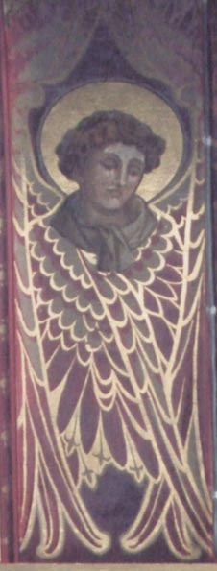

5. The Angels of Our Lady of the Angels

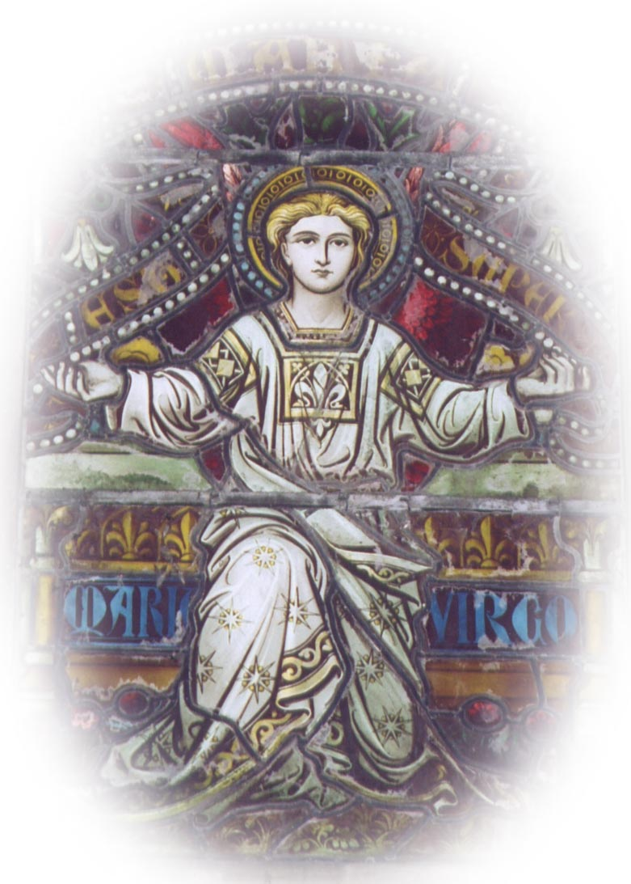

by Francis Young

Introduction

It is nothing unusual for a neo-gothic church to incorporate images of angels into its scheme of decoration, but the former monastic church of St. Mary’s Priory, Princethorpe is exceptional in the large number of representations it contains on account of its dedication to Our Lady of the Angels (177 in total). The second church of the dedication, it was completed and consecrated in 1901 to the designs of Peter Paul Pugin, with many of the furnishings being designed by Joseph Aloysius Pippet. With the exception of some in the north transept, all of the stained glass windows were made by John Hardman and Co. in 1901. Built at the consummation of the Gothic revival, the building exhibits an extraordinarily sophisticated understanding of mediaeval symbolism, although this aspect of the building does not seem to have been appreciated by Pevsner who describes the Pippet furnishings as ‘conservative, not to say reactionary, for their date.’

Most of the imagery is biblical, although the windows also draw upon the ideas contained in the Celestial Hierarchies attributed to St. Dionysius the Areopagite, (See Acts 17: 34) the most famous work of angelology (the branch of theology concerned with angels). In general, however, the images are informed by a careful study of mediaeval gothic art and the distinctive imagination of the craftsman rather than by any overtly scholarly considerations.

The dedication, to Our Lady of the Angels, refers to the Blessed Virgin Mary as Queen of Heaven rather than in her more familiar role as intercessor for mortals. The great west window provides the ‘keynote’ for the whole building, showing the Virgin being drawn up into the very heart of the Trinity to be crowned Queen of Heaven. This spiritual event signals the realisation of humanity’s true nature as higher than the highest of spiritual creatures, since we are elevated to kinship with the Godhead by Christ’s assumption of a human nature. The bodily assumption of the Virgin into heaven as ‘more honourable than the Seraphim and incomparably more glorious than the Seraphim’ (Liturgy of St. John Chrysostom) is the final proof of the efficacy of Christ’s resurrection.

In the same way that the Virgin’s embodied existence was no barrier to her glorification, so these images in wood, glass and stone of higher realities should not prove a hindrance but rather an aid to us in contemplating them—if ‘read’ in this way, they become as much divine messengers as the spiritual creatures that they strive to represent.

The angels are enumerated in this order:
- The West Window
- The Nuns’ Choir and Crossing
- The Chapel of the Sacred Heart
- The Baldachin
- The High Altar
- The Apsidal Windows
- The Ambulatory and Chapels
- The Exterior

1. The West Window: The Coronation of the Blessed Virgin Mary in Heaven

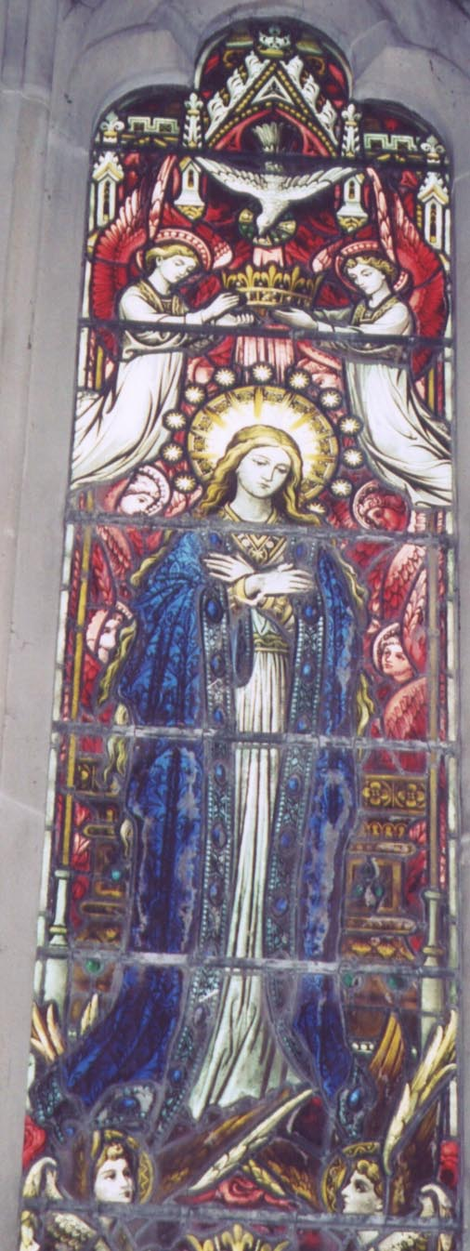
The great west window is one of the richest areas of angelic representation in the church, containing no less than fifty-seven angels. It consists of five major lights, as well as twelve smaller lights in the upper part of the tracery. The window’s symbolism is multilayered, the most obvious level being a representation of the Coronation of the Virgin surrounded by angelic praise. On a closer investigation, however, we see that here the angels crown Mary while Christ and the Father look on: usually it is Christ who crowns. In this window the angels are not mere decorative conceits, but take on a critical role in salvation history.

On one level, the west window is a cosmograph, a map of the pre-modern universe reproduced at the beginning of the 20th Century. A close inspection of composition reveals that it is encircled by four bands of clouds and stars—two red, one gold and one blue. Inside the first red band, wherever a background is discernible behind the figures it is usually one of red stars. Red rays from this central area penetrate all four bands of cloud and stars. The bands are quite clearly representations of the heavens, and a speculative interpretation might identify them with the heavens of Mars (the ‘red planet,’ associated with fire), the Sun (associated with gold) and Venus (associated with water). Their usual Ptolomaic order would be reversed because the events portrayed in the window are happening not on earth but on heaven: the terrene sphere appears as the ground at the very bottom of the window.

The window maps the angelic as well as the physical world. We have already said that the angels are not mere ornamentation; in fact, the window seems to divide them quite neatly into orders and hierarchies. According to Dionysius, the highest hierarchy contains the Seraphim, Cherubim and Thrones. Here, at the top of each light containing one of the Persons of the Trinity the air is thick with Seraphim, the spirits of pure love whose hands, wings and faces are red. Below the thrones of Christ and the Father and the feet of the Virgin we see the Cherubim, whose hands, wings and faces are white. Between these and the five angels whose feet touch the ground are a number of white-clad angels, most bearing Marian emblems on ‘breastplates’ resembling the ephod of the High Priest; their halos are either red, gold or blue. These angels, for the most part, are holding hands in a rapturous dance, but the angels with the red halos seem to be drawing the others upwards. This may be a graphic representation of the doctrine of Dionysius that the superior angels transmit knowledge to the angels lower down in the angelic orders, thereby lifting their understanding to God. These white angels seem to belong to the hierarchy containing the Dominions, Powers and Virtues (the Dominions with red halos, the Powers with blue halos and the Virtues with gold). Finally, the angels at the very bottom of the composition have halos of varying colours and represent either Archangels or Angels, as do the angels in the upper lights who do not form part of the main composition.
At the base of the second, third and fourth lights the large angels hold an inscription in Gothic script, EXALTATA EST MARIA SUPER CHOROS ANGELORUM, which seems to be an adaptation of a verse of the hymn at First Vespers of the Feast of the Assumption in the Roman Breviary, Exaltata est Sancta Dei Genitrix super Choros Angelorum (also the versicle at Second Vespers).

1st Light

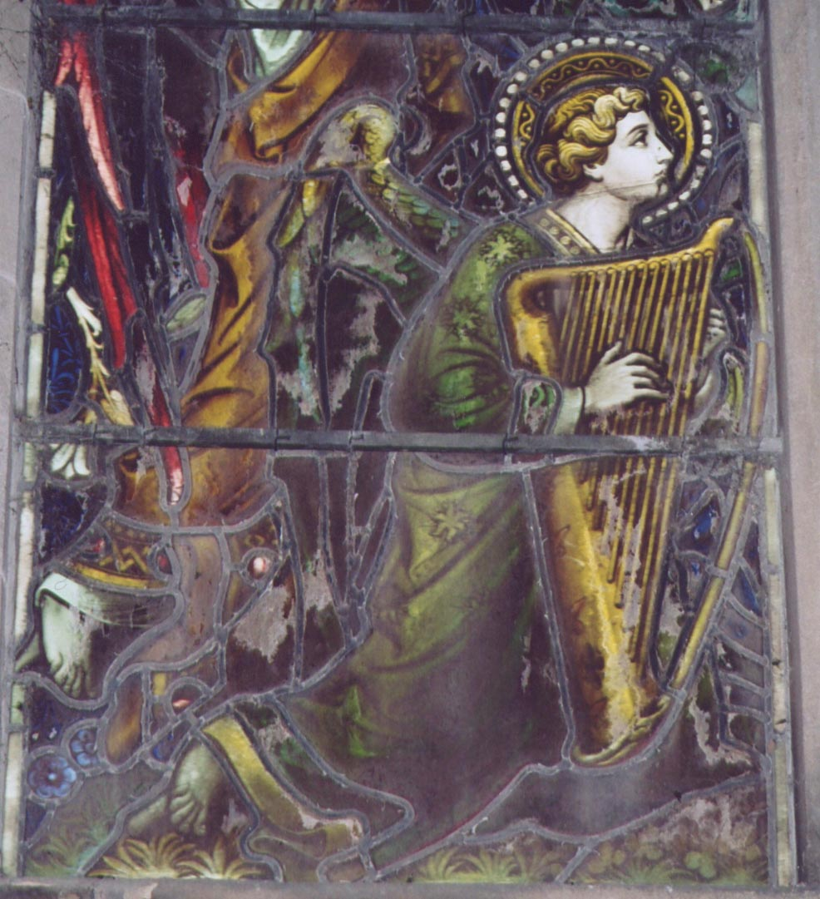
At the very bottom of this light a large kneeling angel plays a golden harp. His moss green robe is decorated with six-pointed fiery stars and his wings are of a similar colour. His halo is gold. Behind him, an angel stands blowing a sort of sackbut (a convoluted horn). The angel wears a white tunic and a saffron overgarment: his wings are purple on the inside and red on the outside, and his halo is blue. Above this angel three smaller angels, all in white with blue wings, join hands. Two of them are wearing ‘ephod’ type garments with a fleur de lys while one of them has a sapphire. The former have blue halos, but the latter has a golden halo and his robe is decorated with seven-pointed rayed stars. At the top of the light two more angels, also in white and holding hands, glance to the right (towards Christ). One has a red halo and his robe is decorated with six-pointed rayed stars, the other has a blue halo.

2nd Light

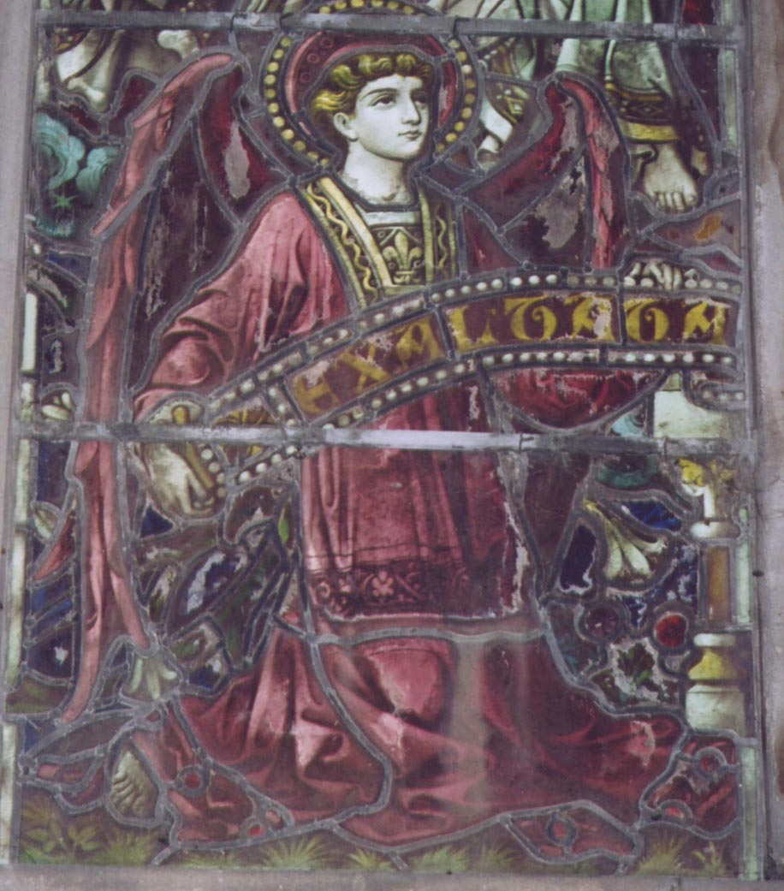
The principal angel of the second light wears a rose tunic with a golden fleur de Lys on his breast. His wings and halo are also rose, and his hands support the first portion of the inscription. Above him, two angels in white link hands; the first bears a sapphire in his ephod and has a blue halo and wings blue on the inside, gold on the outside. The second has blue wings and bears a gold croix patée on his breast. Directly above these two angels, two Cherubim, their hands joined together in prayer, appear to be bearing up the throne of Christ (like the Cherubim in Ezekiel 1, who support ‘the glory of Yahweh’), who is surrounded by five Seraphim.

3rd Light

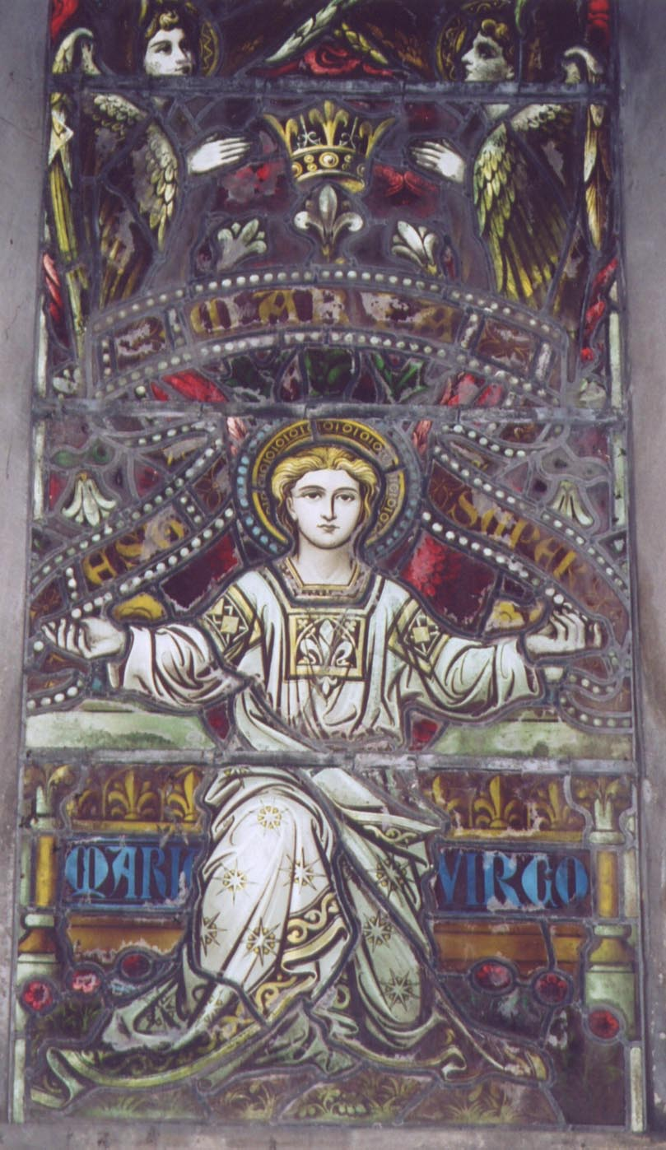
The angel at the bottom of the central light looks straight at the viewer, his hands upraised to support the middle portion of the inscription. Clad in white, he is seated in front of an altar bearing the words MARIA VIRGO. He wears a fleur de Lys ephod and his robes are decorated with seven-pointed rayed stars. The obvious identification of this angel is the Archangel Gabriel, the angel of the Annunciation and Incarnation. Above this angel, two Cherubim, their hands closed in prayer, bear up the Virgin, who is surrounded by six Seraphim. Finally, two smaller angels in white hold the crown above the Virgin’s head. Their red halos and wings suggest that they might be Seraphim. There is some sort of altar directly behind the Virgin. This may be the Ark of the Covenant, making the point that Mary is the Ark of the New Covenant, in which case the west window mirrors the sculpture of the High Altar, which is also a visual allusion to the Ark.

4th Light

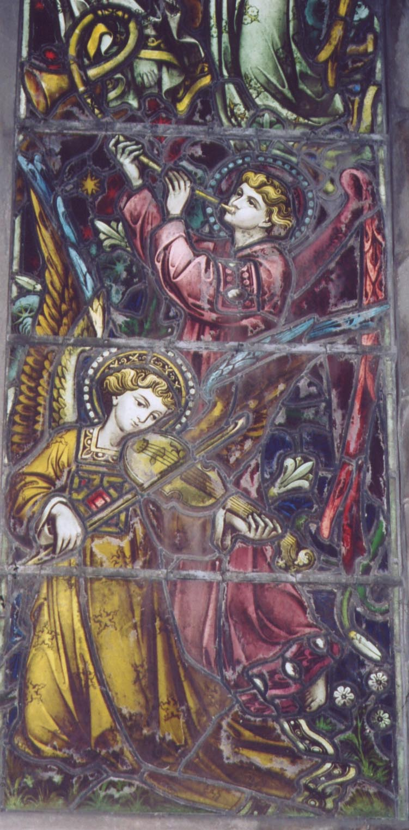
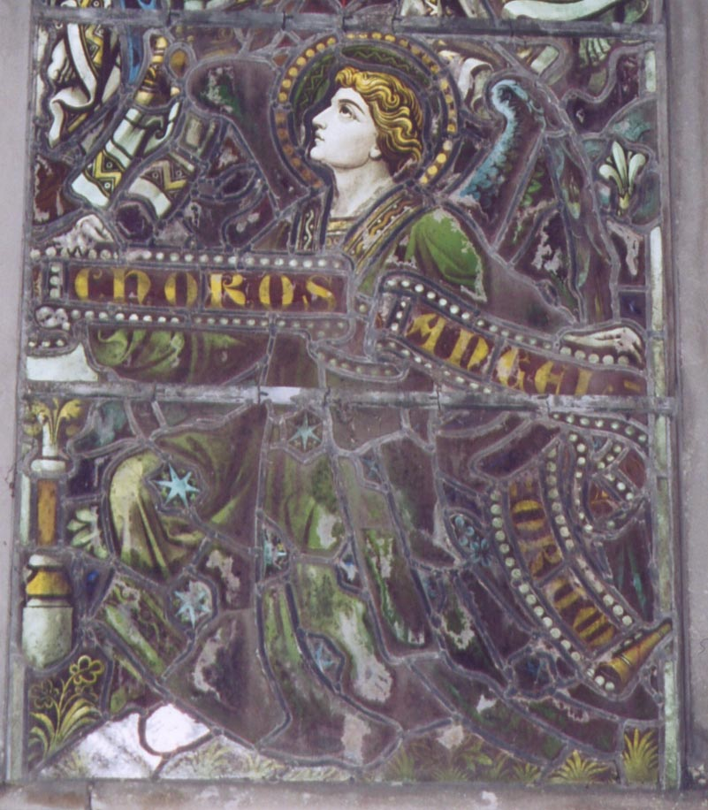
A large angel kneels, holding the end of the inscription, in a moss green robe decorated with blue six-pointed rayed stars. His wings are green and blue and his halo green. Above him two angels in white hold each other’s hands; the first, with blue wings and a blue halo gazes towards the Virgin, while the second has wings blue on the inside and gold on the outside, a red halo, a cross on his ephod and a robe decorated with rayed stars. The second angel seems to be drawing the first angel upwards. Two Cherubim bear up the throne of God the Father, which is surrounded by four Seraphim.

5th Light

A kneeling angel in a gold or saffron robe decorated with five-pointed fiery stars and an ephod set with rubies plays a rebek (a mediaeval violin). Behind him stands an angel dressed entirely in rose, with a rose halo, blowing a long curled horn. Three angels in white with blue and gold wings link hands above them. The first has a blue halo, and wears a fleur de Lys ephod and robes decorated with what seems to be a ‘mystic rose’ emblem (although it may also be the Trinitarian emblem of a rose with three heads). The second has a gold halo and robes decorated with the Trinitarian triangle emblem, and the third has a blue halo and fleur de lys ephod. At the top of the light, a white angel with a red halo and fleur de lys ephod draws up an angel identical except for a blue halo, by both arms.

The Upper Lights

Left Bottom: An angel in white with blue wings, a gold halo and a robe decorated with six-pointed rayed stars plays a rebek.
Left Left: An angel in white with green wings and a green halo plays a flute.
Left Right: An angel in white with blue wings and a blue halo plays the cymbals.
Left Top: An angel in white with slate grey wings and a rose halo plays the viol.
Centre Bottom: An angel in white with saffron wings and a red halo plays the bass drum.
Centre Left: An angel in white with red wings and a saffron halo plays the sackbut.
Centre Right: An angel in white with rose wings and a gold halo plays the tuba.
Centre Top: An angel in a white robe decorated with six-pointed rayed stars with green wings and a green halo plays the triangle. The shape of the triangle, at the very top of the ogival arch, is doubtless intended to have Trinitarian resonances.
Right Bottom: An angel in a white robe decorated with six-pointed rayed stars with saffron wings and a red halo plays a cithern.
Right Left: An angel in white with blue wings and a gold halo plays a hoboy.
Right Right: An angel in white with rose wings and a blue halo plays some sort of bassoon.
Right Top: An angel in a white robe decorated with five-pointed flowers with green wings and a saffron halo plays the double pipes.

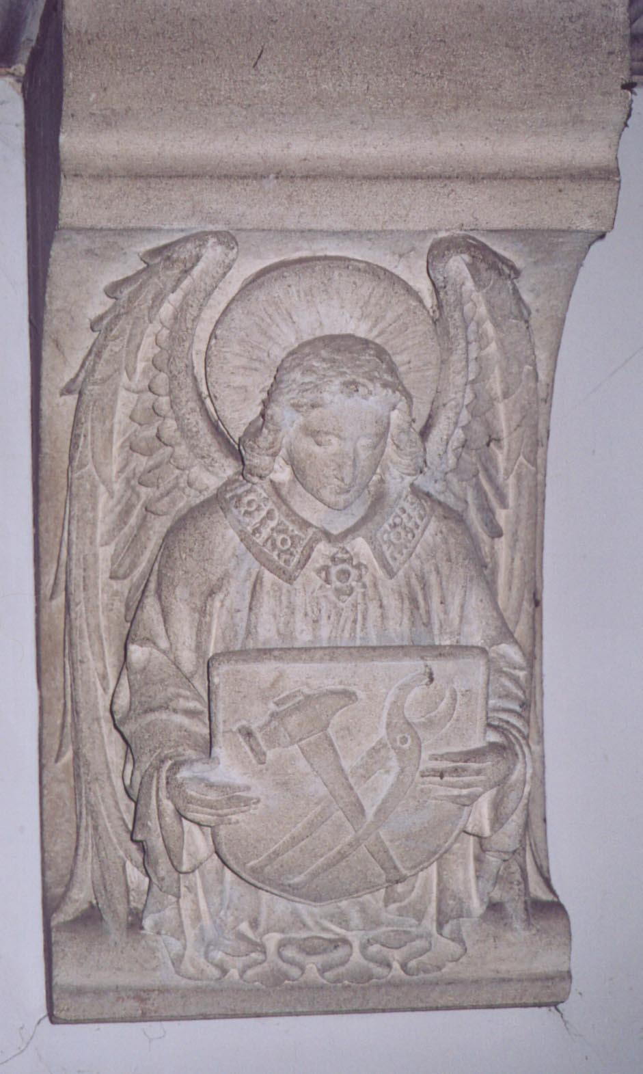

2. The Nuns’ Choir and Crossing

At the west end of the main body of the church, or nuns’ choir, stands the statue of Our Lady of the Angels on a carved wooden pedestal and under an elaborate canopy. On the pedestal there is a relief of the crucifixion, and the two smallest angels in the chapel are flying up to the hands of the crucified Christ to catch the Precious Blood in chalices.
Three unpainted stone angels on each side of the choir in liturgical vestments bear shields with emblems of the Passion. These emblems were originally carried in procession on the Feast of Corpus Christi but, as the Corpus Christi devotion gained prominence in the later Middle Ages they became permanently incorporated into church architecture. They are, on the north side, the hammer and pliers; the ladder and spear; the cross, crown of thorns, spear and hyssop. On the south side they are the nails; the pillar and scourges and a chalice representing the Agony in the Garden. The emblems are probably intended to be ‘read’ around from the southeast (the chalice) to the northeast (the cross). In the crossing, two further angels, one above the Infirmary Gallery and another over the Organ Loft, hold shields bearing an image of an empty cross.

The choir has seven stained glass windows on each side. On the north side, in the window depicting the Flight into Egypt, an angel in white, with a green halo and golden wings, flies across both lights protecting the Holy Family with a flaming sword. A little further on, in the second light of the window depicting St. Margaret Mary Alacoque’s vision of the Sacred Heart, the head of Christ is surrounded by three Seraphim (whose faces, interestingly, are white rather than red), while four Cherubim are gathered around his feet.

On the south side of the nuns’ choir a window depicts the Nativity, and naturally enough two angels appear in the first light, with red wings and golden halos, holding the inscription GLORIA IN EXCELSIS DEO. In the second light of the window depicting the Annunciation, Gabriel appears in a white dalmatic with red tassels overhanging his shoulders, standing on a small blue cloud. His halo is golden and his wings red, and in his hand he carries a lily sceptre. There is a red tongue of fire in his halo, reflecting the depiction of the Archangels in the ambulatory. The inscription AVE MARIA GRATIA PLENA covers the lower part of his body.

3. The Chapel of the Sacred Heart

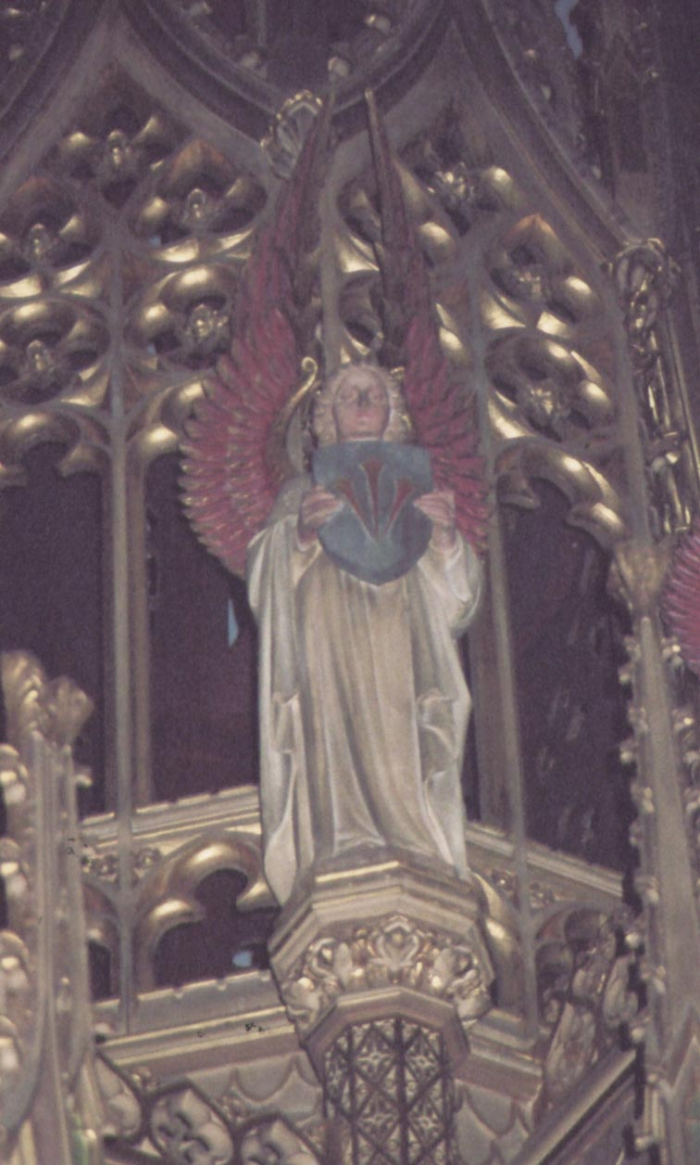
The painted angels on Pippet’s reredos in the Chapel of the Sacred Heart wear white tunics and mantles; their halos are gold and their wings red. The four kneeling in the foreground, on both sides, are carrying thuribles, while the four standing behind play musical instruments. These are, from left to right, a tambourine, a rebek, a psaltery and a sackbut.

4. The Baldachin

The magnificent wooden baldachin surmounting the High Altar bears four distinct sets of angels, all designed by Pippet, beginning with the four large Archangels set at the four corners. Inside the roof of the baldachin itself there are four angels holding shields, as well as painted images of Seraphim, and high up on the canopy, beneath the crowning pelican, are six angels bearing the emblems of the Passion.

The Four Archangels

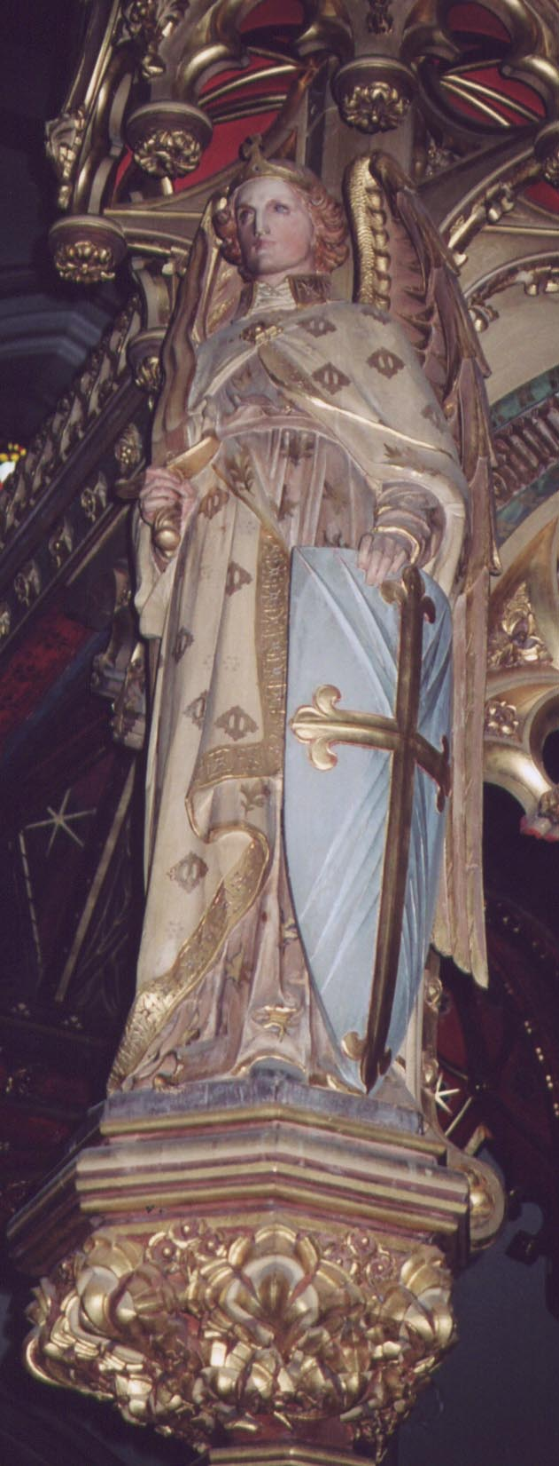
These wear plain gold circlets surmounted, above the forehead, by a cross. The ‘cross-diadem’ is a relatively common motif seen, for example, in Jan van Eyck’s representation of the Archangel Gabriel in the Ghent Altarpiece or in the glass of St. Michael’s Priory, Great Malvern, one of the best collections of mediaeval angelic representation in England. The resemblance of the circlets to crowns associates them with archangels in particular, since they are said to have sovereignty over human nations and cultures. It therefore seems almost certain that the angels of the baldachin are the four Archangels Michael, Gabriel, Raphael and Uriel (the latter appears in Chapter 20 of the apocryphal Book of Enoch, but not in the Bible itself).
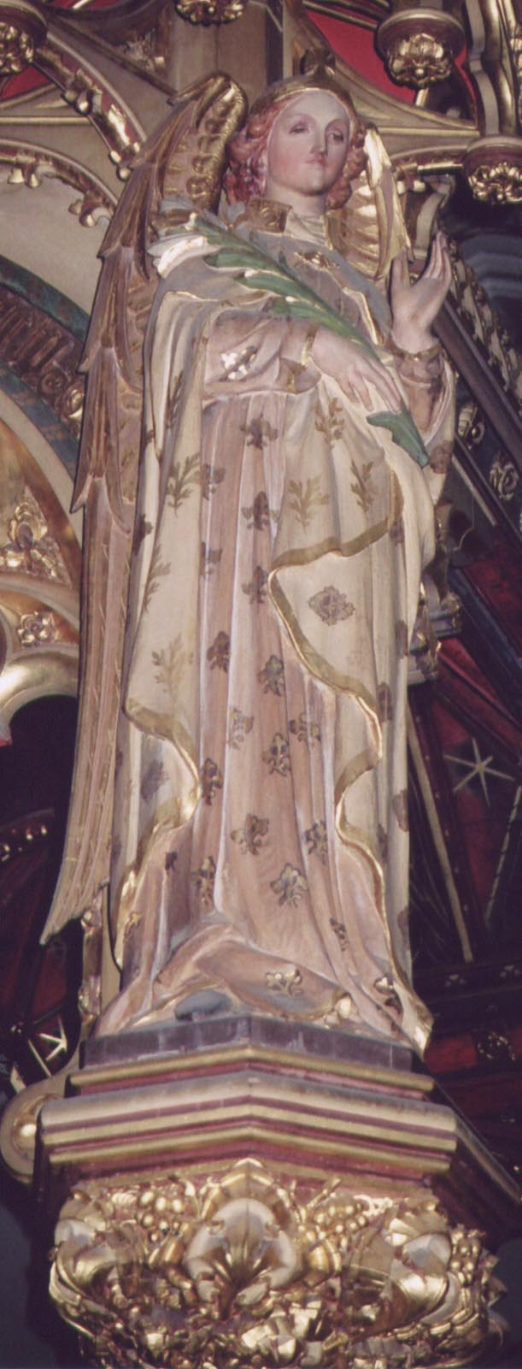
On the northwest corner of the Baldachin the Archangel Michael is represented carrying a flaming sword and resting on a blue shield which bears a gold cross fleurée radiating pale light. The colours of his tunic and mantle, as of the other angels, are masked by dirt at the time of writing, but they appear to be rose (tunic) and red (mantle). The tunic is decorated with stylised flames or oak leaves, and the mantle with a letter ‘M.’

At the southwest corner, Gabriel carries what should be a lily but more closely resembles a martyr’s palm. His tunic is decorated with flames or stylised oak leaves and his mantle with a letter ‘G.’

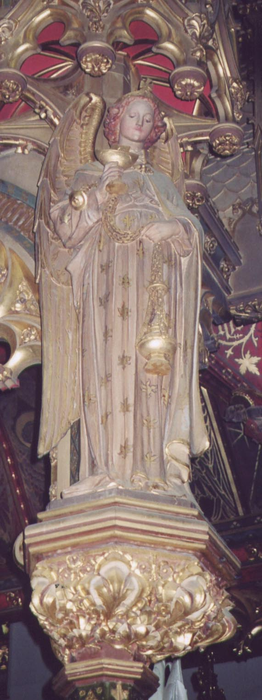
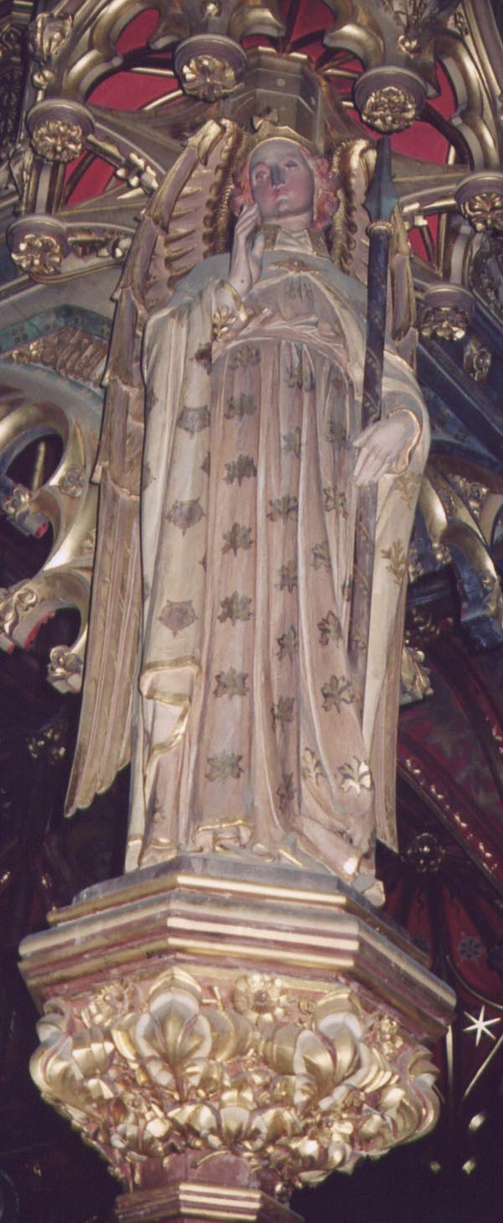
Walking round the baldachin, at the southeast corner, we see an Archangel carrying a golden thurible and incense boat. His tunic is covered in stylised flames or oak leaves and his mantle in fleurs de lys. He is probably Raphael, since it is Raphael who identifies himself as ‘one of the seven holy angels who present the prayers of the saints,’ (Tobit 12: 15), and in Revelation we hear that ‘the smoke of the incense rose with the prayers of the saints from the hand of the angel before God’ (Revelation 8: 4).

The Archangel at the northeast corner of the baldachin must therefore represent Uriel, the revealer of mysteries, who guides Enoch through heaven in the apocryphal Book of Enoch. He carries a spear and his hand is raised in blessing. The spear may represent his penetration of hidden mysteries.

The Four ‘Sanctus’ Angels

Underneath the baldachin, again set at the four corners only looking inwards towards the High Altar, are four small angels in blue with red wings holding red shields; these all bear the words ‘Sanctus’ written diagonally across them.

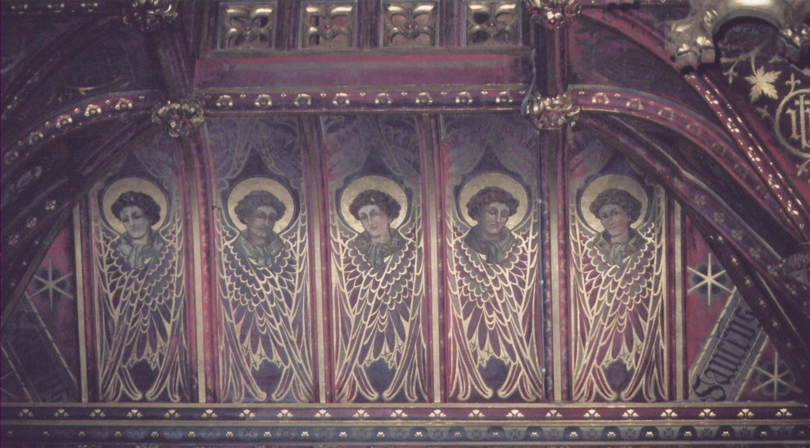
The Nine Seraphim

On the inside of the canopy, on the north and south sides, are painted five Seraphim with golden halos and folded wings. On the east and west sides there are only two.

The Six Angels of the Passion

The six white-robed angels of the Passion are of roughly half the size of the Archangels, although their red wings are of a conspicuous height. All carry shields depicting the traditional emblems of the Passion on a blue field. These are, on the west side, the nails and the crown of thorns; on the north side, the ladder, hyssop and spear and the seamless robe; on the east side, the pillar and scourges and the cross flanked by the sun and moon; on the south side, the hammer and pliers and the thirty pieces of silver arranged in a circle.

5. The High Altar

Three marble columns rise out of the top of the tabernacle. The central column, which is the highest, bears the crucifix, while the other two are surmounted by Pippet’s angels kneeling in adoration with their hands folded across their shoulders. The obvious interpretation of the tableau is the angels’ adoration of the cross, but on reflection a deeper symbolism suggests itself. The angels above the tabernacle recall the Cherubim on top of the Ark of the Covenant (the ‘tabernacle’ of the Old Covenant), whereas the platform of the crucifix would correspond to the ‘mercy seat,’ since the cross is the fountain of divine mercy.

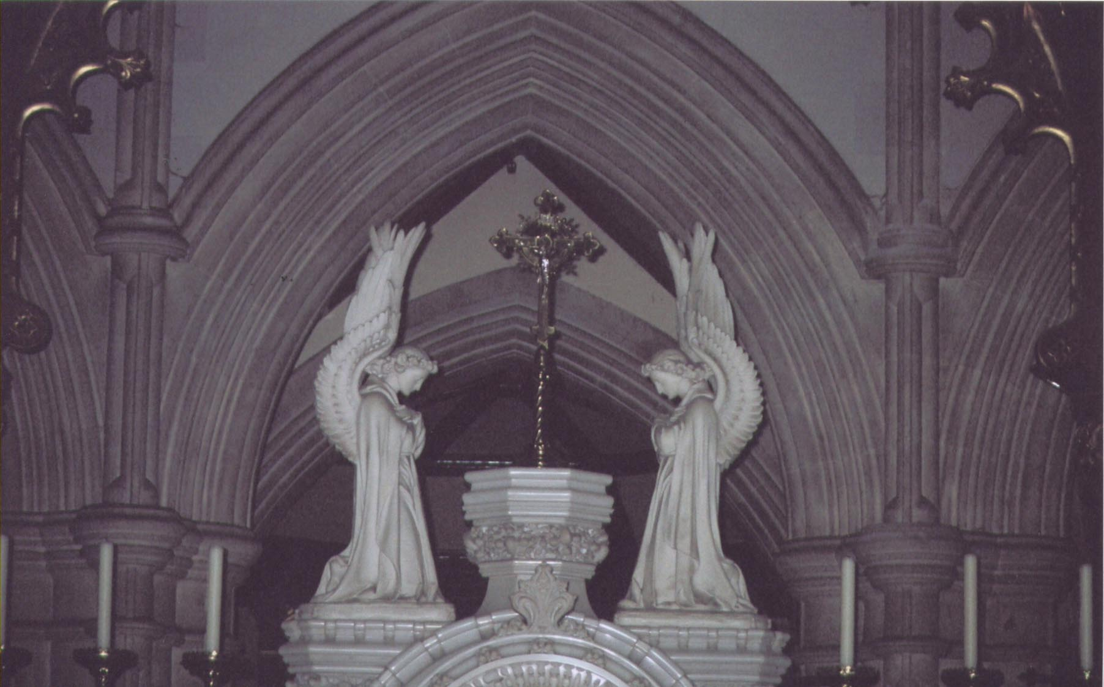

6. The Apsidal Windows

The nine windows of the apse are decorated, appropriately, with images of angels from the nine orders or hierarchies of angels in the uppermost quatrefoils, although space has been made in the central window for the Holy Spirit, reducing the number of hierarchies represented to eight.

From north to south, the orders represented are the Thrones, Dominations, Cherubim, Seraphim, Virtues and Powers. The imagery does not follow the hierarchical order, but the names of the orders are drawn not directly from Dionysius but from St. Gregory the Great, who gives the name of the fifth order as Virtues (‘Authorities’ in Dionysius).

The angel representing the Thrones is dressed in white with a golden halo and violet wings: he holds a castellated tower, presumably representing the Divine stability that the Thrones embody. The legend THRONI is written across the light. The next light bears the word DOMINATIONES, and the angel, again in white, has a blue halo and green wings: he is holding a large orb surmounted by a cross, representing Christ’s dominion over the whole world. The third angel, labelled PRINCIPATUS, with a golden halo and blue wings, is crowned and holds a palm branch in his right hand. This is presumably a reference to Revelation 7: 9, where the saved who are to rule with Christ carry palm branches in their hands. Further on, the window on the left hand side of the central window contains an image of a Cherub with red and gold wings in the quatrefoil tracery, together with the legend CHERUBIM. On the south side, a Seraph mirrors the Cherub on the north side. The angel has blue, gold and red wings and a golden halo, and the legend SERAPHIM is inscribed across the quatrefoil. This is followed by a white angel with a blue halo and gold wings in the quatrefoil carrying a scroll with the words AVEAVEAVE. The angel is marked ANGELI. The angel marked VIRTUTES has a golden halo and blue-green wings, and is swinging a large golden censer. Finally, an angel holding a sword with a red halo and green wings represents the POTESTATES.

The corbels on either side of each of the nine apsidal windows take the form of stone Cherubim consisting of a head and one pair of wings. The central window consists of exclusively angelic imagery. It contains the same cosmograph (bands of red, gold and blue clouds and stars) as the great west window. At the bottom of the first light a small angel in white with a golden halo and green and blue wings holds up the dedicatory inscription at the base of the window. Above him, a large angel in a white dalmatic with blue wings and a green halo encircled by seven stars plays the rebek. Finally, a smaller angel in white with a golden halo and purple wings swings a censer. At the bottom of the second light there is a small window similar to the first, but with gold and purple wings. Above him an angel in a white dalmatic decorated with seven-pointed stars, green wings and a golden halo surrounded by six stars plays the hoboy. Another angel with blue wings swinging a censer completes the light, although the quatrefoil bears an image of the Holy Spirit descending on the sanctuary.

7. The Ambulatory and Chapels

The Altar of the Holy Child Jesus

Two carved stone angels kneel on either side of the image of the Child Jesus on the reredos. Their halos are gilded but their bodies and wings unpainted. The angel on the left holds the inscription Laudamus te, the one on the right Benedicimus te. On the altar itself two angels kneel on either side of an image of the Nativity with their hands together in prayer.

The Vision of St. Teresa

This window depicts St. Teresa of Avila’s vision of the Child Jesus. Three angels in white with white and gold halos adore on either side of the Holy Child. At the bottom of the first light, the angel’s hands are closed in prayer; his wings are gold and his robes decorated with a three headed rose or triple trefoil motif. Behind this angel stands another with blue and purple wings, his hands crossed on his shoulders; two Seraphim are just visible to his right. At the top of the light there is a praying angel with rose wings, and above him a Cherub.

In the central light, the Holy Child is surrounded by ten Seraphim, while two Cherubim hover above them.

In the third light are three angels similar to those in the first. Two more angels in prayer, one with green and the other with rose wings attend an angel with gold wings and arms crossed. Again, two Seraphim are visible and a Cherub completes the light.

The Chapel of Our Lady of Sorrows

A window on the north side of the chapel depicts St. Mary Magdalene carrying the crown of thorns away from Calvary, followed by St. John and the Blessed Virgin. Above them, an angel robed in white decorated with six-pointed stars flies with a golden halo and red and saffron wings, wringing his hands.

The Window of the Three Archangels

The window depicts the three Archangels named in Scripture, Michael, Raphael and Gabriel. The inscription ANGELIS SUIS MANDAVIT DE TE runs across the top of all three lights. In the first light St. Michael is depicted in golden chainmail and armour, over which he wears a tunic decorated with eight-pointed stars and a fiery cross on his breast. His tunic is tied with a purple girdle, and he holds a flaming sword in his right hand and a pair of scales in his left. His wings are green and a gold flame appears in his halo. In the second light St. Raphael takes the boy Tobias by the hand. He wears a long robe decorated with croix pommées radiating light, and holds a tall staff with a water bottle tied to its head. The archangel’s wings are red and his feet crush the demon Asmodeus, depicted as a red snake. Like Michael’s, his halo contains a yellow flame. Finally, in the third light Gabriel wears a splendid gold dalmatic with the word AVE written on its breast and green tassels over his shoulders. In his left hand he holds a lily with five heads; his wings are blue and there is a yellow flame in his halo.

The Altar of St. Benedict

In Pippet’s reredos painting of St. Benedict enthroned, two white angels with gold halos stand on either side of the saint’s throne.

8. The Exterior

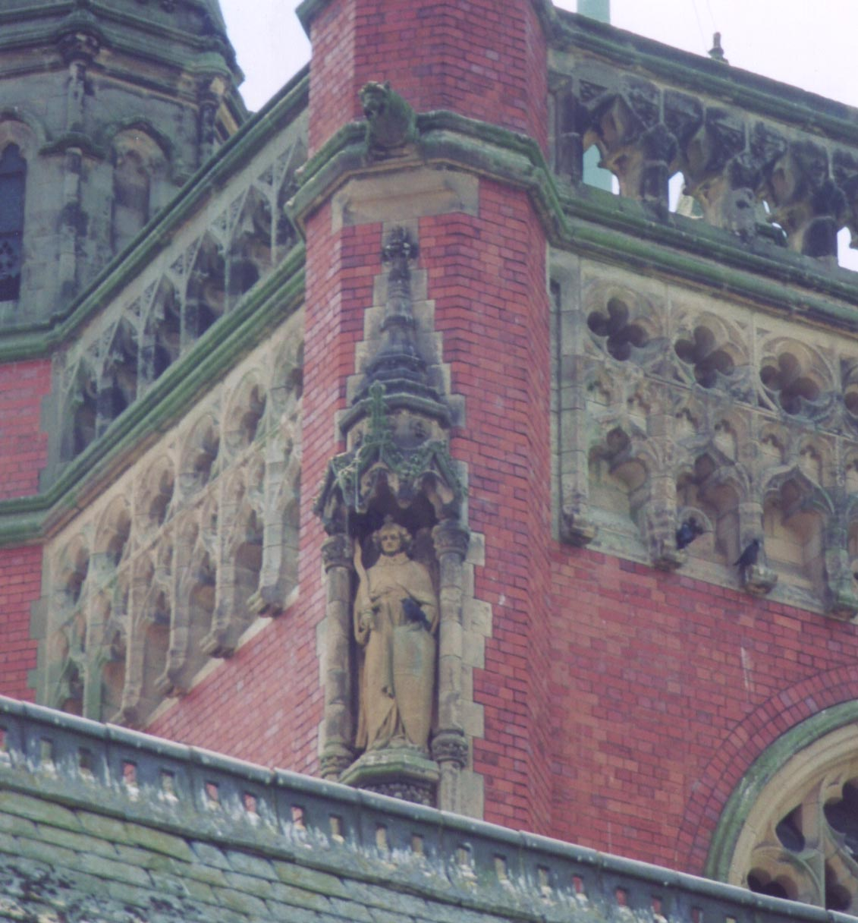
What appear to be exact copies in red sandstone of three of the four wooden Archangels at the corners of Pippet’s baldachin adorn the exterior of the church tower among other statues. Michael faces northeast, Uriel faces north and Gabriel faces southwest. There is no sign of Raphael.

Note

At the time of writing the windows of the Church of Our Lady of the Angels are in a deteriorating condition. Several are broken and many are bulging outwards, away from the glazing bars, allowing fractures to develop.

Francis Young
Princethorpe College, 4th July 2003

Acknowledgements

The assistance of Stephanie Bennett, Alex Darkes and Carola Dahrenmöller is gratefully acknowledged as contributing to the completion of these notes.

Further Reading

O’Donnell, R., The Pugins and the Catholic Midlands (Archdiocese of Birmingham Historical Commission, 2002)
Pevsner, N., Buildings of Warwickshire (1966)
Stapleton, F., A Short History of the Benedictines of St. Mary’s Priory, Princethorpe (Ditchling, 1945)
History of the Benedictines of St. Mary’s Priory, Princethorpe (Hinckley, 1930)


© 2008
The Princethorpe Foundation
Revised edition - December 2011

Buildings of Warwickshire, 1966
On the other hand, there is a precedent for this in the glass of the former chapel, now Princethorpe College Library, where a flying angel with red wings places the crown on the Virgin’s head.
Alternatively, the bands of colour might represent the three orders of the first hierarchy. In angelological literature the orders are associated with different elements: the Seraphim with fire (red), the Cherubim with earth (gold/brown) and the Thrones with water (blue).
Dionysius identifies the Throne of God as an order of spiritual creatures in its own right.
O’Donnell (The Pugins and the Catholic Midlands, Archdiocese of Birmingham Historical Commission, 2002) identifies the altar at Princethorpe as a development of the ‘benediction-altar’ type (p.106).
Homily 34
This is a solitary example of non-gothic decoration in the church.
Psalm 91: 11-12 and Luke 4: 10

