
Princethorpe
College

Motoring Festival News
May 2012

Seventeenth Motoring Festival to take place on Sunday 24 June at Princethorpe College


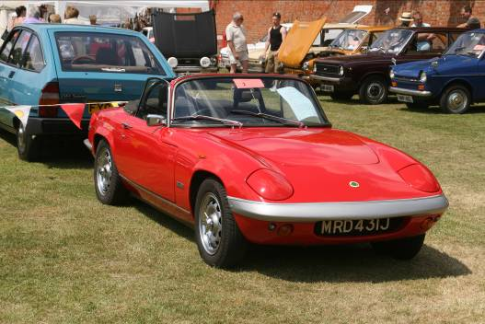
2012 SEES our seventeenth Motoring Festival at Princethorpe, which takes place on the same afternoon as the Summer Fête – 24 June - and as usual there will be displays, stalls, sideshows and other attractions for all of the family.
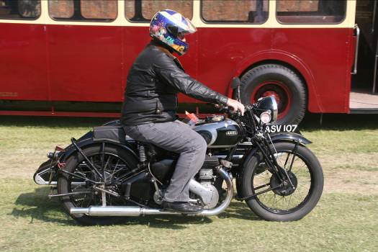
Invitations have been extended to motoring clubs and already many parents and friends have agreed to bring along cars, motorbikes and commercials. There will be rally plaques for all pre-booked vehicles and awards for self-judged competitions.

Usual road run at 11.00am…

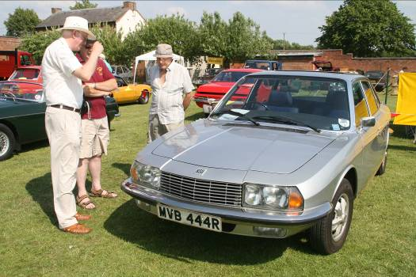
THERE WILL be another informal morning road run of about 30 miles through local countryside, with a route book. Vehicles taking part in the run need to arrive at Princethorpe for 11.00am. Food will be available for a nominal charge on return to Princethorpe at lunch-time, or feel free to bring a picnic.

The Festival is open to anyone keen to bring any sort of classic, vintage, veteran or interesting vehicle along for the afternoon. We are also still keen to hear from anyone in the motor trade who might be able to sponsor one of the awards. Motor clubs will be most welcome; please get in touch.

If you can help or would like to bring a vehicle along, please complete the
attached slip, returning it as soon as possible to Alex Darkes, Princethorpe College, Rugby, CV23 9PX.
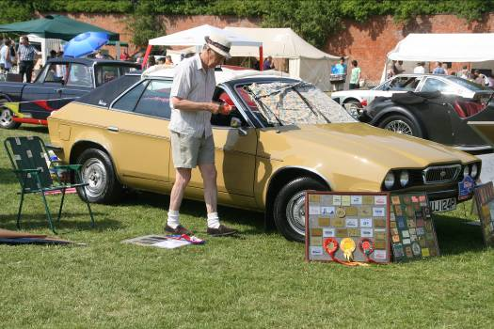
Telephone enquiries 01926 634207 Fax 01926 633365 e-mail alexdarkes@princethorpe.co.uk
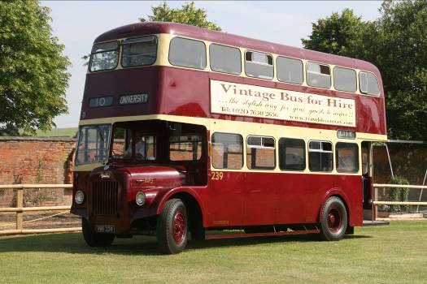

Register a vehicle on line by going to www.princethorpe.co.uk and follow the link to the Motoring Festival page


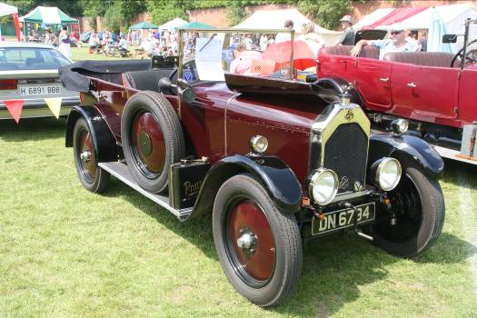
Filling in the form in no way commits anyone, but gives us an idea of the number of vehicles to expect.


_______________________________
Please tell your friends!

Further information and maps will be posted about one week before the event.

Please feel free to photocopy this leaflet.
Warwickshire Catholic
Independent Schools Foundation
Princethorpe College 11 to 18
Crackley Hall School 2 to 11
www.wcisf.co.uk
WCISF Company registered in England & Wales and Limited by Guarantee Number 4177718 Registered Charity Number 1087124
Registered Office Princethorpe College Princethorpe Rugby CV23 9PX



It is now possible to register on line at www.princethorpe.co.uk. Follow the link to the Motoring Festival page.
Motoring Festival 2012

Name _________________________________________

Address _________________________________________

_________________________________________

Postcode ________________________________

'Phone Number ________________________________

Email address ________________________________

Vehicle ________________________________

Registration No ________________________________

Are you hoping to display your car with other members from a car club of which you are a member? YES/NO

If YES, which car club? ______________________________________________

Will that car club be bringing a display banner? YES/NO

Have you taken part in the Festival before? YES / NO

I am interested in taking part in the morning road run YES / NO

Please return this slip as soon as possible by fax e-mail or post to Alex Darkes, Princethorpe College, Rugby, CV23 9PX. (Telephone enquiries 01926 634207 Fax 01926 633365 e-mail alexdarkes@princethorpe.co.uk) Filling in the form in no way commits anyone, but gives us an idea of the number of vehicles to expect.

Only tick this box  if you forbid this information to go on Princethorpe College’s database which will only be used for the purpose of promoting the Motoring Festival and the data will not be disclosed to any third party.


Please feel free to photocopy this form and to tell your friends about the event!
Registered office as above. Company registered in England & Wales and Limited by Guarantee Number 4177718 Registered Charity Number 1087124

